ONLINE GAMING INDUSTRY

ABSTRACT :

Online gaming can have multiple effects on an individual’s life and this topic has been a frequent topic of discussion in academia. Since the late 1990s, blame began being placed towards gaming violence for driving criminal activity, especially mass murder. The media has been a major cause of this discussion and, as a result, many research studies have been conducted in order to explain why some individuals have become violent or anti-social after gaming. Despite the wealth of information available, there have been conflicting results regarding the influence of gaming on people and few researchers are in agreement regarding the influence on the mental health of players. It considered the frequency of gaming per week, the number of years of gaming, and different ways it affects their life and relationships with others. Other information considered is feelings experienced while engaging in game play.

OBJECTIVES :

Altogether, playing online games help players develop complex problem-

* solving skills, leadership skills, and the ability to deal better with unexpected consequences.
* To prepare students to work in teams. to prepare students to improve their skills and knowledge related to specific job positions individually.
* To develop creativity and individuality in problem solving and performing tasks. To enable students to do self-study.
* Online gaming is one of the widely used leisure activities by many people. For some people it is said that playing video games has a number of reasons to be played.
* For it can be a stress reliever, challenge and competition, relaxation, enjoyment, social interaction, and even mentally escaping from the real world.

INTRODUCTION :

We all like to play games, as it is considered to be one of the most intriguing activities for amusement and leisure. Be it Candy crush or free fire the craze for games in India has been on top. It is often said that this fun activity has the power to make you happy as it increases your brain function, releases serotonin which is a chemical that makes us feel delightful Well, the allure of playing games is not new, be it board games or virtual games, the excitement of it has always increased in India. After the technological advancement and the history of gaming has completely changed and transformed.

* The one prominent area which did not get relatively affected by the Covid-19 pandemic was the gaming industry all over the world. In fact, the pandemic lockdown gave a boost to this industry since people were forced to sit at their homes and explore some leisure activities.
* According to a survey, there was a 30% increased in traffic in online mobile gaming in India during this period. Also, Paytm First Games reported that they saw an increase of 200% in the users of this online gaming platform.
* Gaming Industry is the economic sector involved in the development, marketing and monetization of games. Gaming Industry In India is valued at 60 Billion in 2019 and is expected to reach 250 Billion in 2024.
* The gaming industry is growing in India with a very high growth rate because India has the world’s largest youth population and embracing the new generation’s interest in digital sports and entertainment.

**LITERATURE SURVEY:**

* MMORPG :**-**

The history of MMORPG was born in 1970s and was started as a “Multi User Dungeons (MUDs)” on the Advanced Research Projects Agency Network (ARPANET) back in the mid-1970s and currently this industry is continue to grow rapidly (Daniel & Daniel, 2012, chap. 41; Hou et al., 2011; Lo & Wen, 2010; Rezaei , 2014). MMORPGs are form of MUD games that offer a persistent 3D virtual world to support thousands of players to playing together on the Internet or PCs (Lo & Wen, 2010). “In an MMORPG, the world exists before the user logs on, and continues to exist when the user logs off” (Yee, 2006).

In the year of 2003, “Rag Online”, on of MMORPG licensed from Gravity Corporation, South Korea. It was localized into Thai language to serve Thai gamers. “This game was an immense success, with the highest peak Concurrent Users of over 110,600” (ASIASOFT CORPORATION PUBLIC COMPANY LIMITED, 2013).

MMORPGs brought a significant role in online game player interactions within game industries. MMORPG users experience more complicate gaming behaviour compared to other virtual games players so this issue leads to further research in the MMORPGs industry (Strong, and cry-Exner (2011); Rezaei, 2014). In software industry, software developer which provide consumers with personalized product based on individual preference have been shown to be better choices (Murray , 2009).

## **Player type study **:****

## One of the major concern about MMORPGs study is to identify the motivations of game players to engage in gaming environments. Bartle’s (1996) player taxonomy was among the first studies to describe player motivations in virtual worlds. Bartle’s (1996) player type theory was stated that there are four main reasons why people continue playing Multi-User Dungeon (MUDs: ancestors of MMORPGs) which are to achieve in the game, imposition others, explore through the game, and socialize with other players. This theory first start off with taxonomy of game players of MUDs or Multi-User Dungeon which is the multiplayer online game that allow many players to join at the same time. According to Bartle’s player type theory, there are four things that people typically enjoyed personally about MUDs were:

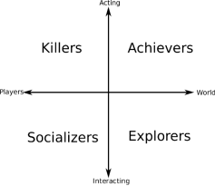

TRIUNE BRAIN THEORY :

Triune Brain theory was invented by Paul McLean in 1968. The theory itself separate human brain into three layers which works differently for each part (McLean, 1990). It consists of the reptilian brain (core brain), the limbic system (mid layer), and the cerebral system (outer layer) (McLean, 1990â€¬) which is described as follows:

The Reptilian brain functional to controls every basic function of our living. It maintains patterns and habits of human body and controls primitive behaviour, sensation, and survival. Environment does minimal effects to this part of brain.

The Limbic system is considered to be primary centres of emotion thinking, form and sequence which play a key role in memory transformation and retrieval (Andrew, 2001). McLean acknowledges that the senses we feel about the rationality of our thoughts has its roots in this system of emotional intelligence (McLean, 1990).



Zee(2003) and Young (2005) also mentioned :

1. Excessive mental effort on internet
2. Spending hours even though being intended to spend couple of minutes
3. Exposure to health problems due to spending hours in front of the screen each time
4. Continuously waiting for the next connection time
5. Feeling more comfortable contacting people over internet than talking face-to-face
6. Decrease in meals, lessons or work efficiency due to using internet or staying connecting
7. Trying to give or spread the mail address, chat room names etc to everybody
8. Continuously feeling sleepless and tired because of staying connected to the internet until late
9. Having failure in attempts to decrease the internet usage
10. Withdrawal syndrome due to increase in the internet usage
11. Telling lies to family members, therapist or others to be able to stay connected to the internet
12. Having affection changes in the duration of internet connection (Young, 1999; cited in *et. al*., 2007; cited in, Balta 2008).

#### ADVANTAGES :

#### **It helps reduce stress.**

#### **It elevates one’s mood.**

#### **It enhances the development of social skills.**

#### **It improves concentration.**

#### **It provides a source of income.**

DISADVANTAGES :

1. Physical Health Issue.
2. Insomnia.
3. Lack of concentration.
4. Poor Academic performance.
5. Lead to social isolation.

RESEARCH METHADALOGY:

Descriptive associational research method has been used for this study. The aim of the descriptive perspective is to determine related cases. This type of research is used to demonstrate associations and relations between two and more variables (KASHMIR, 2009).

The Population and Sample of the Study:

The population of this research involves all high school students in North Cyprus. The sample for the research consists of 61.8 % (n=81) female, 38.2 % (n=50) male, total 131 high school students. The sample was selected through criterion sampling method of the purposive sampling. Students who had their own personal computers were set as a criteria.

Comparing Students’ Gender with

Online Game Addiction Scale Scores

|  |  |  |  |  |  |  |  |
| --- | --- | --- | --- | --- | --- | --- | --- |
| **Subscales** | **Gender** | **N** |  | **Sd** | **df** | **F** | **p** |
| **Troubles** | **Female**    **Male** | 81    50 | 1.57    2.28 | .64    1.06 | 129    71.79 | 25.11 | .000** |
| **Success** | **Female**    **Male** | 81    50 | 2.38    3.26 | 1,15    1.12 | 129    105.6 3 | .773 | .000** |
| **Economic**  **profit** | **Female**    **Male** | 81    50 | 1.42    2.38 | .59    1.34 | 129    61.28 | 50.60 | .000** |
| **OGA General Scores** | **Female**    **Male** | 81    50 | 1.85    2.67 | .71    .88 | 129    87.88 | 1.50 | .000** |

FINDINGS:

* For the google survey the total number of responses we

get is 40.

* It is about the development of online gaming industry from past years.
* The responses we got on type of games you like
* Action-adventure :- 59%
* Simulation :- 7.1%
* Multi-player :- 28.9%
* Strategic :- 5.1%
* The opinion on online games
* It gives entertainment :- 71.1%
* It reduces stress :- 28.9%
* The favourite games among them
* GTA V :-23.1%
* FREE FIRE :-43.6%
* PUB G :-25.6%
* GOD OF WAR :-7.7%
* Is online games helps to develop skills
* Yes :-82.1%
* No :-17.9%
* Rating on online gaming industry
* 1 :- 2.6%
* 2 :- 0%
* 3 :- 28.2%
* 4 :- 30.8%
* 5 :- 38.5%
* Comment your favourite game
* BGMI :-15.6%
* FREE FIRE :-84.4%
* Do you think professional gamers are similar to athletes
* Yes :-56.4%
* NO :-43.6%

DATAANALYTICS :

It is about the online gaming industry development and people’s response on the online gaming. The responses are recorded from the google forms.

There are mainly four types of games :

1.Action-adventure

2.Simulation

3.Multi-player

4.Strategic

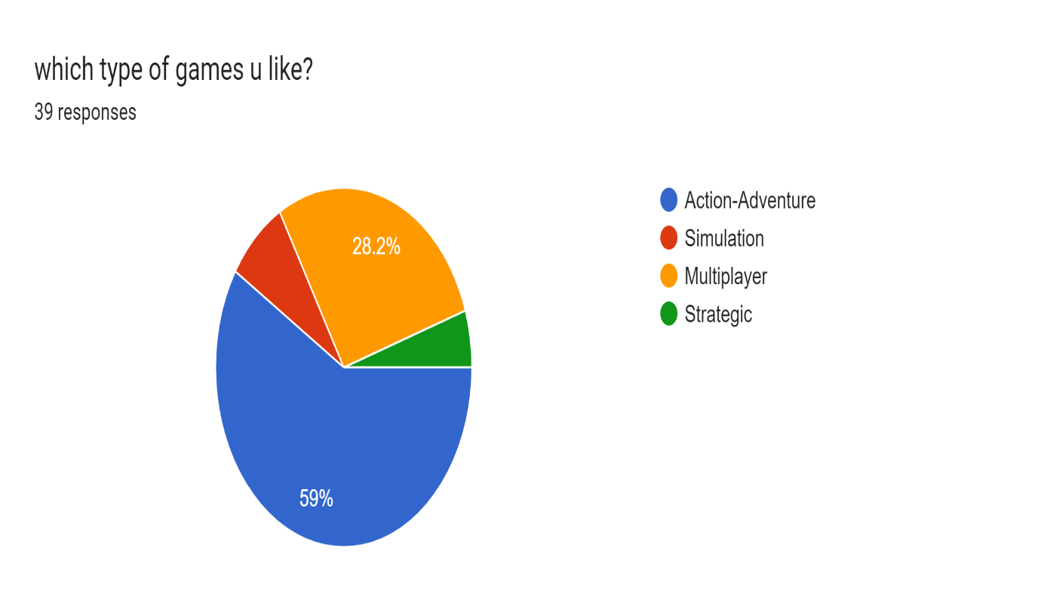

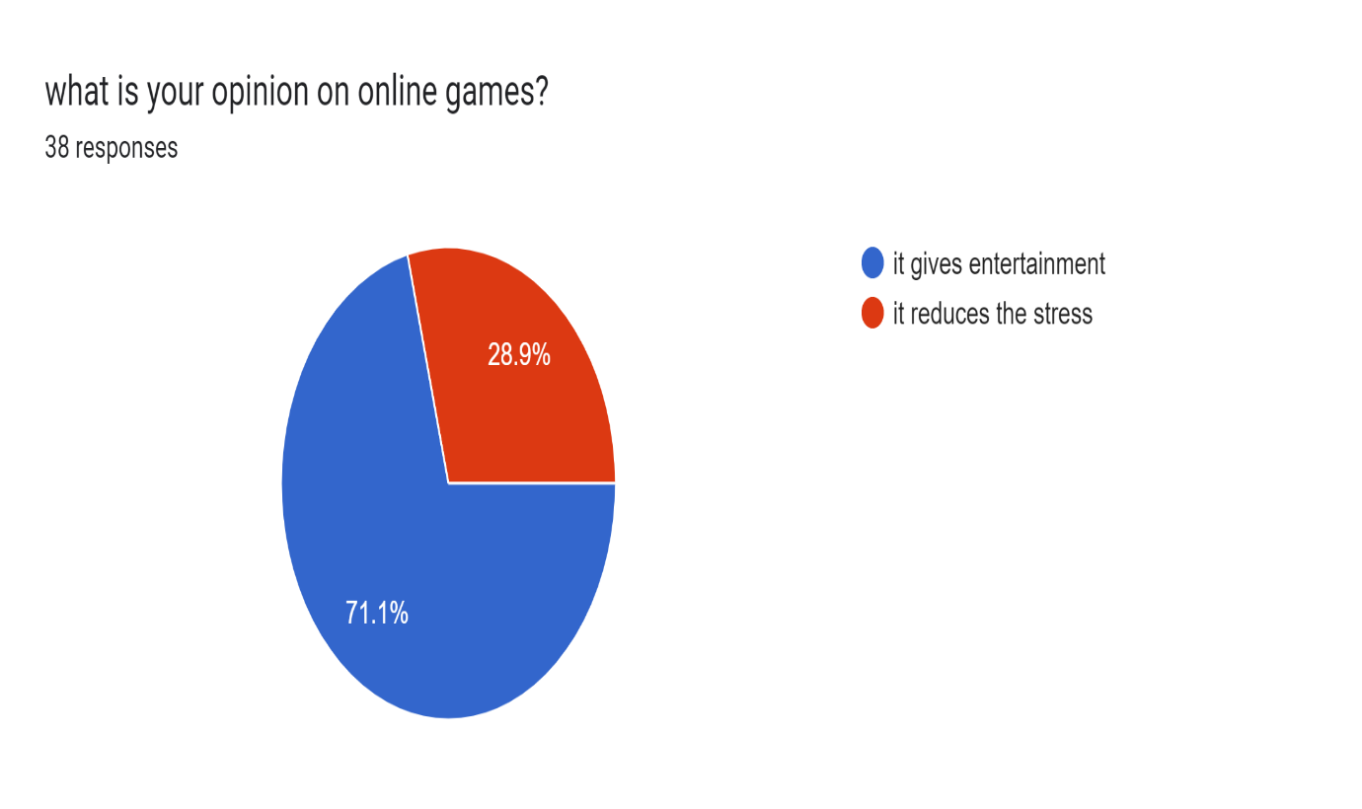

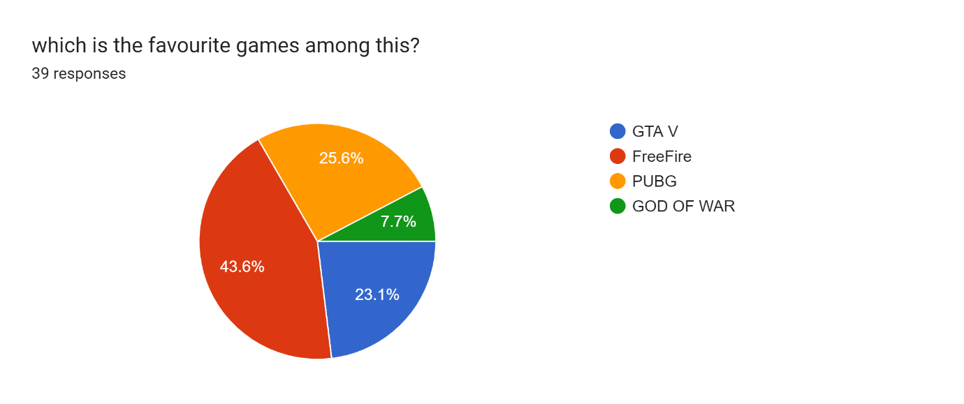

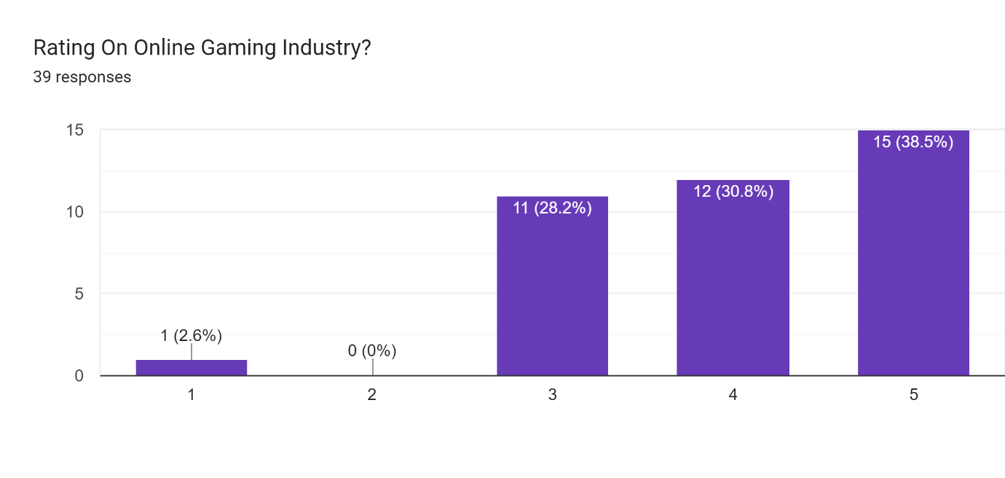

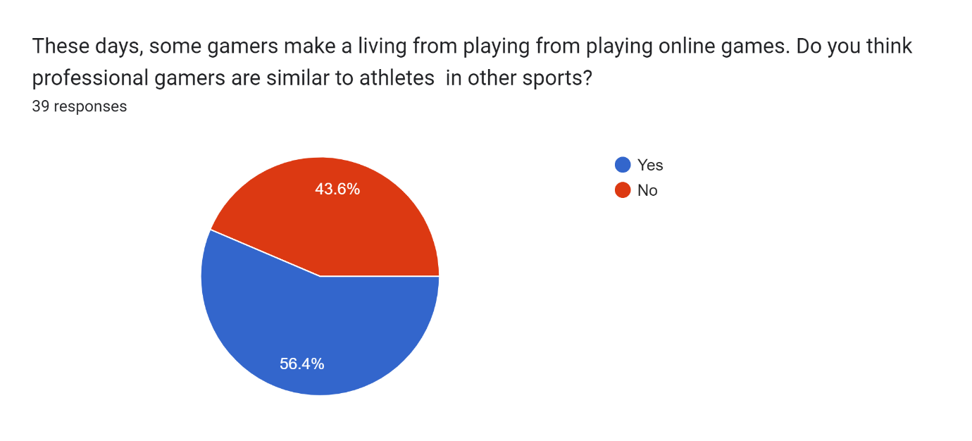

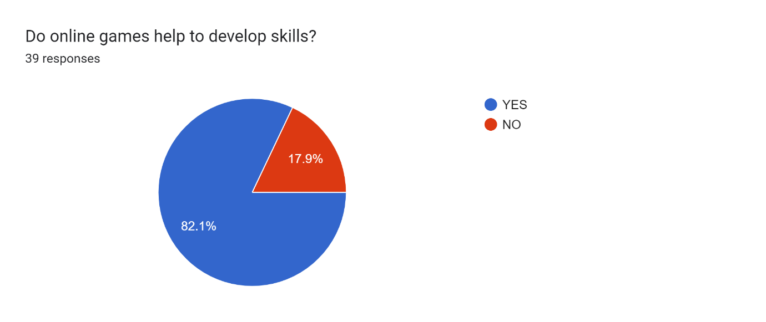

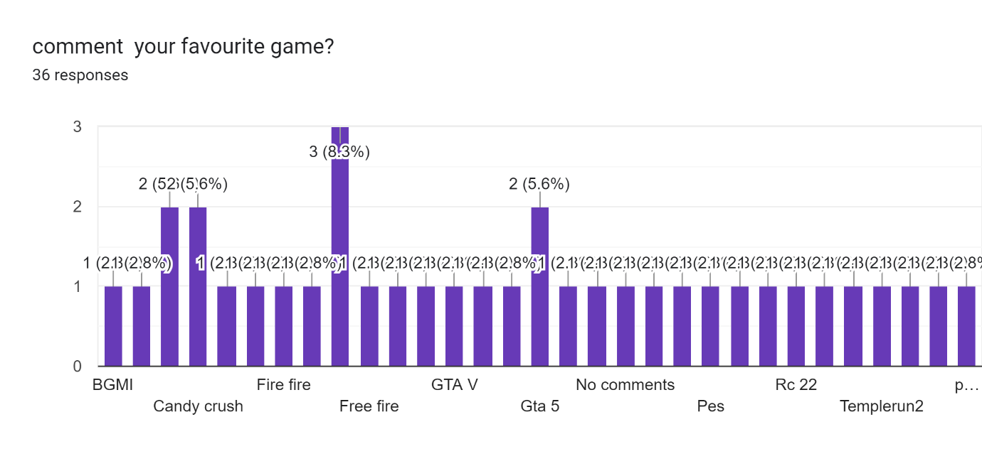

FUTURE ENHANCEMENT of Gaming Industry:

1. Age and gender dominance is likely to improve in the near future. Online gaming will soon see a shift in the age and gender composition of the total population since the huge untapped market is likely to experience this world of gaming

2. Cloud gaming is going to get very popular especially in India. All people would need to have is a stable internet connection and they could get an experience of gaming like never before.

3. Freemium companies will help the industry to get better economic conditions. We are a very price-sensitive market and freemium gamers would continue to search for alternatives if the companies start charging for premium services.

4. Emerging technologies will help our country to uplift the gaming industry even more. The use of artificial intelligence augmented reality in games, virtual reality, modular technology, and cloud based gaming infrastructure will be the key drivers of the gaming industry in the future.

CONCLUSION :-

The present study focused on the high school students that use their own personal computer for playing online games and develop game addiction. As related with the findings, we are aware of the effects of online game addiction on gender differences. Only adolescents, who attend private high school and come from the families with higher socio-economic status and education, have participated in the study. Having a large sample of students with different backgrounds may enable to generalize the results to the population. The further studies could be applied to other age groups such as secondary or university students in order to obtain a variety of views on the issue.

Considering the results of this online gaming habits or addiction it is recommended to provide training to the students about the positive and negative aspects of online games. In addition, students having online gaming habits are suggested to develop awareness about troubles that come with addiction.

REFERENCES:

Church-Sanders, Rachel. "Special Report: Online Poker – Industry Trends." IGB Affiliate. Web. 4 April 2016. http://www.igbaffiliate.com/resources/articles/special-report-online-poker-%E2%80%93-industry-trends.

* John. "PLATO for Education and Training." PLATO. John 2008. Web. 4 April 2016. http://www.daleske.com/plato/.
* Goldstein, Hilary. "The Top 10 Xbox Live Games." IGN. Ziff Davis, LLC. 23 April 2004. Web. 4 April 2016. http://www.ign.com/articles/2004/04/22/the-top-10-xbox-live-games?page=4.
* Grubb, Jeff. "Gaming advocacy group: The average gamer is 31, and most play on a console." VB. Venture Beat. 29 April 2014.Web 2016. <http://venturebeat.com/2014/04/29/gaming-advocacy-group-the-average-gamer-is-31-and-most-play-on-a-console/>.
* "The History of Online Gambling." OnlineGambling.com. 11 June 2013. Web. 4 April 2016. http://www.onlinegambling.com/online-gambling-history.htm.
* Witkop, Lorie . "Top 5 Most Popular Online Games for Women." Love to Know. Corp. Web. 4 April 2016.
* Balta, Ö. Ç. M. B. (2008). The factors that affect internet addiction of students in a web based learning environment. *Journal of Faculty of Educational Science*, 41(1), 187-205.
* Chou, C., Condron, L. & J., C. (2005). A review of the research on Internet addiction. *Educational Psychology Review,* 17(4), 363-388.
* Hyun, G., J, Han, D., H., Lee, Y., S., Kang K., D., S., K., Chung, U. & Renshaw, P., F. (2015). Risk factors associated with online game addiction: A hierarchical model. *Computer in Human Behaviour,* 48, 706713.
* Holland Kim, J., K. & Kim, Y. (2013). Self-traits and motivations as antecedents of digital media flow and addiction: The internet, mobile phone and video games. *Computer in Human Behaviour,* 29, 2416-2424.
* Tone, H., Zhao, H. & Yan, W. (2014). The attraction of online games: An important factor for Internet addiction. *Computer in Human Behaviour*, 30, 321-327.
* Wan, C., S. W., B. (2006). Why are adolescents addicted to online gaming? A interview study in Taiwan. *hyper Psychology & Behaviour,* 9(6), 762-766.

TOP GAMING COMPANIES IN WORLD:

Rockstar Games

Ubisoft